Armenia: Recent Economic Developments and Outlook

# GDP growth in 2019 increased

GDP growth increased from 5.2% in 2018 to 7.6% in 2019. On the demand side, private consumption, accounting for 84.5% of GDP, contributed the most with 8.5 percentage points (pp). Government expenditure shared 1.4pp. Net exports gave 0.8pp. On the other hand, gross capital formation shaved 3.1pp from growth. On the supply side, services, accounting for 54.2% of GDP, contributed the most with 5.4pp. Industry (including construction) gave 2.3pp. However, agriculture shaved 0.6pp from growth.

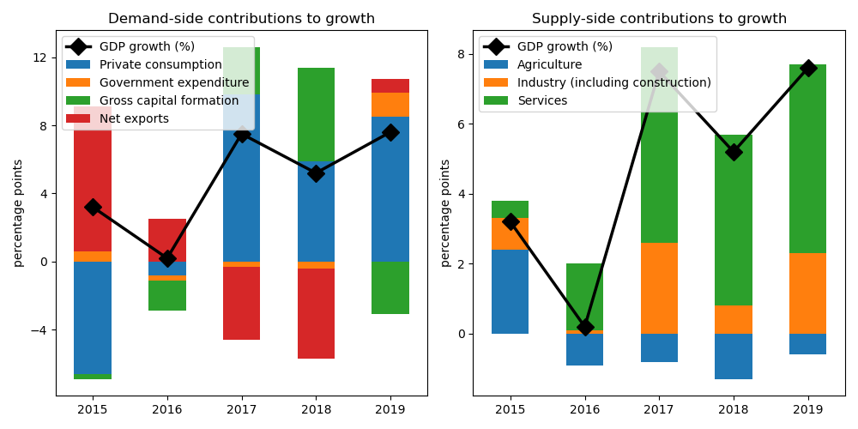

## Government expenditure achieved largest gain on the demand side

Government expenditure increased by the biggest margin at 12.5% annual growth. Private consumption picked up by 10.3%. Net exports picked up by 0.9%. On the other hand, gross capital formation declined by 13.8%.

## On the supply side, growth in services accelerated the fastest

Services picked up by the largest edge at 10.3% annual growth. Industry (including construction) increased by 9.1%. On the other hand, agriculture contracted by 4.0%.

## Unemployment plunged; inflation improved

Unemployment rate plunged from 19.0% in 2018 to nan% in 2019. Consequently, inflation improved from 2.5% to 1.4%. At the end of the year, the central bank set the policy rate at 3.0%.

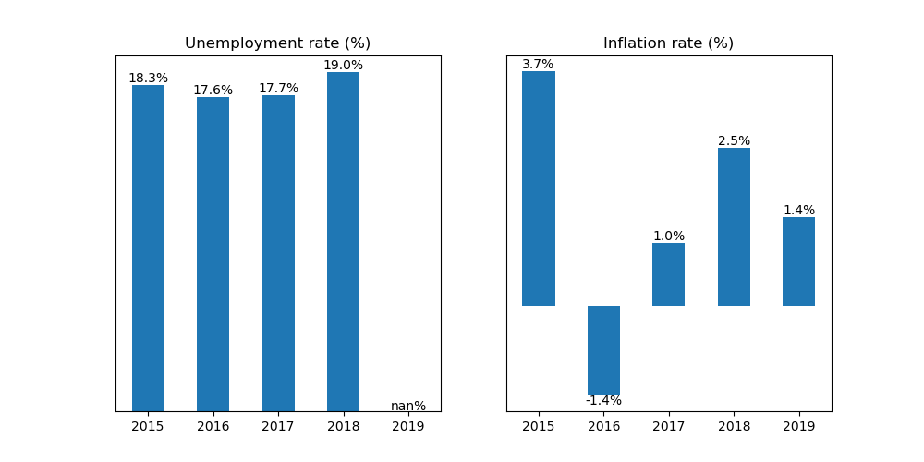

## Current account balance posted a deficit

Current account balance (CAB) recorded a deficit at 7.2% of GDP in 2019. Net trade in goods and services reached USD -1.8 billion. In 2018, CAB posted a deficit at 6.9% of GDP.

Russian Federation is the country's top export destination accounting for 27.2% of total exports in 2019. Other major exports partners include Switzerland (17.5%), Bulgaria (7.9%), China (7.4%), and Iraq (6.8%). Top export commodities are ores, slag and ash, accounting for 25.5% of total exports.

For imports, top imports origin in 2019 is Russian Federation (29.2% of total imports), followed by China (14.7%), Iran (6.4%), Turkey (5.3%), and Germany (5.0%). Major import commodities are mineral fuels, mineral oils and products of their distillation; bituminous substances; mineral waxes, accounting for 15.1% of total imports.

# Output contracted in Q3 2020

Output plunged by 9.1% year-on-year in Q3 of 2020. Growth in overall economic activity improved from a contraction of 13.7% in the previous quarter. Government expenditure expanded by the biggest margin at 6.9% annual growth. On the other hand, the rest of the components, namely exports, imports, gross capital formation, as well as household consumption, shrank by 44.7%, 36.1%, 11.4%, and 8.0%, respectively.

## Retail sales contracted

Retail sales contracted by 13.3% year-on-year in September of 2020. Growth in the retail sector improved from a contraction of 16.5% in August, reflecting increased trade activity.

## Industrial output expanded

Industrial production expanded by 3.3% year-on-year in September, an increase from 0.8% growth in the previous month. Growth in manufacturing declined to -0.1% from 0.2%.

## Inflation improved

Overall inflation improved to -1.6% year-on-year in October from -1.4% in the previous month.

Armenia's central bank held unchanged the official policy rate to 1.75% in November from the same in October.

# Outlook tilted downwards this year

On November 2020, Consensus Economics panelists project Armenia's economic growth ending in 2020 at -5.7%. In 2021, the panelists foresee growth at 4.9%. Industrial production is seen to grow by -5.7% and 6.2%.

Meanwhile, Consensus Economics panelists foresee inflation averaging in 2020 at 0.9%. In 2021, the panelists project inflation at 1.8%.

*Sources: Consensus Economics, The World Bank, UN Comtrade, Haver Analytics, and National Sources. Accessed 05 December 2020.*